Editor’s note:
- Delete all highlighted text before submission.
- All instructional text in each section should also be replaced.
- Make use of the predefined styles in the document to mark up your text.
- Take special care to format graphs, images and tables carefully. Make sure to include descriptive captions.
- If you are unsure of how a specific section should look, consult a few high quality published journal articles to understand what is expected.

Descriptive article title that describes the aim of the study

Name Surname 1, Name Surname 2 [replace with names and surnames]

- Abstract (150-200 words)
Replace this with your abstract text. Your abstract should give readers a summary of your article. It should concisely describe the contents of your article and include key terms. It should be informative and accessible, and not only indicate the general scope of the article but also state the main results obtained and conclusions drawn. The abstract should be complete; it should not contain undefined abbreviations, and no table numbers, figure numbers, references, or equations should be referred to. Use UK (not US) English throughout your article. Do not capitalise words that are not proper nouns.

- Introduction (400-600 words)
The introduction of your article should do the following (see http://sana.aalto.fi/awe/style/reporting/sections/intros/cars/cars.html for more detail):
Explain the general layout of the research area by describing current features/characteristics of the area, as well as why it is an important field and who has already been working on it. Explain the need for this specific research project by showing where current research is “incomplete”/showing that there are areas where the field still requires further investigation (i.e., show where the gap is). State how the current research project fills this gap and contributes to the research which has already been done.

The introduction section is a summarised general overview of the study. This includes formulating the topic of study as a problem statement within the larger context, i.e., why it is worth studying this specific topic in the first place. This essentially means pointing out the “gap” that your study aims to address.
Your introduction section should also give a brief overview of how you actually addressed the problem/gap and what insights you gained; in other words, it should contain a brief summary of the Methods and Discussion.
At the end of this section, you would typically include your research questions. Do not include them in a table like you did in the deliverables. Rather, introduce the main question, followed by the sub-questions and briefly discuss their inclusion in the project.

- Literature review (600-800 words)
Cover the literature required to clarify to the reader why you did this study and to provide the background for your work. This should not be your full literature review; you must summarise this review into an overview that covers the most important concepts relevant to the study and can be referred to later to answer the literature-based sub-research questions of your study (see the discussion section below).

- Sub-heading 1
Lorem ipsum dolor sit amet, consectetur adipiscing elit. Fusce eu euismod neque. Proin vitae velit ullamcorper, porta magna non, tempus massa. Vestibulum auctor feugiat est id tincidunt. Vivamus nec mauris elementum ante facilisis ultricies sed a risus. Phasellus nisi risus, blandit eget odio vitae, ornare tincidunt metus.

- Sub-heading 2
Lorem ipsum dolor sit amet, consectetur adipiscing elit. Fusce eu euismod neque. Proin vitae velit ullamcorper, porta magna non, tempus massa. Vestibulum auctor feugiat est id tincidunt. Vivamus nec mauris elementum ante facilisis ultricies sed a risus. Phasellus nisi risus, blandit eget odio vitae, ornare tincidunt metus.

- Methods (800-1200 words)
How did you answer your research questions? There should be enough information in this section to allow another researcher to repeat your experiment. Look at other papers that have been published in your field to get some idea of what is included in this section. In addition to general details about your research methods, you should also include the following subsections:

- Participants
Discuss details regarding your final sample (i.e., number of participants, demographic information) as well as your sampling method with motivation. Mention relevant ethical considerations made regarding the use of human subjects in your research.

- Materials
Discuss all materials involved with the data collection, including a description of the software application(s) you used during data collection. This description should include motivations for design choices made in the application itself and include at least one screenshot of the application (Note: your final submission does include a video of your software, but watching this should not be necessary to understand the paper).

- Procedure
Describe the procedure followed during data collection by providing a brief summary of what participants did, which data were collected and how, and any other relevant information. If you used a complicated protocol, it may be helpful to include a diagram, table, or flowchart to explain the methods you used. This section should also briefly discuss how the data were handled after collection.

- Results (800-1200 words)
Use the work done in deliverable 7 to write this section in the following format:
Provide each empirical sub-research question as a sub-heading and then answer the question by providing the data gathered. This includes providing relevant graphs and tables and then discussing their relevance. Each sub-section should be targeted to answer the sub-research question specifically.
For quantitative analysis, you need to include descriptive statistics, in this case the mean and standard deviation, and the test results for normality, e.g., Shapiro-Wilk test. Based on the results of the test for normality you will select the appropriate statistical test, e.g., a t-test vs. Mann-Whitney U test. For whichever test you use, your test results must be reported in the standardised APA format.
For qualitative analysis, refer to the provided guides for reporting on thematic analysis, including generating a thematic map to summarise your main codes, categories, and themes.

Graphs should only be included if they meaningfully support the discussion and illustrate results in a way that cannot be clearly described in the text. Graphs should not contain titles. Instead, their contents should be clearly described in the caption. They should always contain axis labels and legends where necessary. A graph should be able to stand on its own without explanation. However, all graphs, figures, and tables must be referenced in the text (e.g., Figure 1 shows the positive relationship between variables x and y). Try to include the graph, table or figure directly after the paragraph where it is referenced.
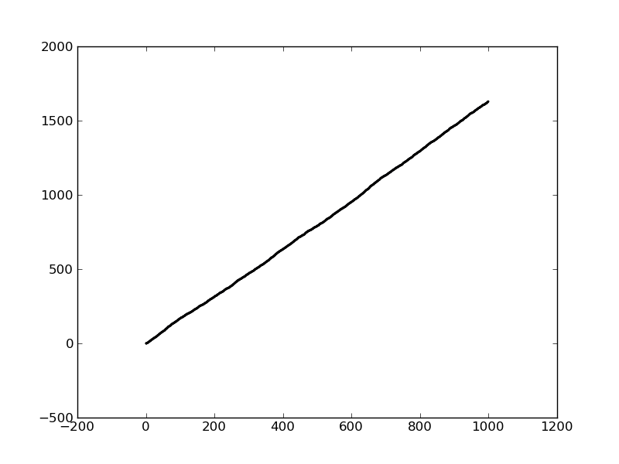
Figure 1: This is a clearly-worded caption for a graph, image or table. Figures and graphs should be numbered as Figure 1, 2, 3, etc.

Table 1: Table captions should be placed above tables. Tables should be numbered Table 1, 2, 3, etc. Tables should only contain horizontal lines to separate sections, not grid lines for every row. Vertical lines should be avoided unless necessary. Column and row headings should be in bold and numbers should be centred.
Course | Condition | N | Pre-test completed | Post-test completed | Both tests completed
A | Condition 1 | 15 | 13 | 13 | 12
A | Condition 2 | 14 | 13 | 11 | 11
A | Condition 3 | 13 | 11 | 11 | 10
B | Condition 1 | 23 | 20 | 7 | 7
B | Condition 2 | 26 | 24 | 13 | 12
B | Condition 3 | 27 | 26 | 7 | 6
Total |  | 118 | 107 | 62 | 58

- Discussion (800-1200 words)
Use the answers from the sub-research questions to answer the primary research question.
First, answer any literature-based sub-research questions. This should be done by referencing relevant sections of the literature review section of this paper and drawing everything together into a clear answer.
Then, draw from the answers of all the sub-questions to answer the primary question. This should result in a cohesive discussion of the research problem and the way in which your study contributes to the gap in the field.
Your discussion should not simply be a repetition of your results, but should be an interpretation of what your findings mean in the context of your research topic. For example, if your results are non-significant, you should provide possible explanations as to why this was the case with reference to existing research and in a way that supports or refutes what is known about the topic.

- Implications (400-600 words)
Discuss the broader implications of this research by explaining how your results fit into the bigger picture of the research in this field. Are your results consistent with what other investigators have reported? If your results were unexpected, try to explain why. Is there another way to interpret your results?

- Limitations (200-400 words)
All scientific research has limitations and providing these limitations is important for readers to understand the results with reference to these. Describe the main limitations that factored into the data collection and analysis. These should be clear and forthcoming, in other words, do not try to hide or downplay the factors that were likely to have had an influence on the final results and discussion. The limitations should also be contextualised to the specific study, e.g., simply stating that the sample size was small is not sufficient; you should be able to explain the implications of a limited sample size within your study.
- Future work (200-400 words)
Discuss how your study might inform future areas of research. This should be specific to the focus areas of your study and should refer to insights gleaned from your results, in other words, what further research would be necessary to answer the questions raised by your results?

- Conclusion (200-400 words)
Briefly conclude the article by referring back to the introduction section and the way in which this study addresses the gap in the literature. Do this by restating the gap and then highlighting the most important results from this study.

- Critical reflection (600-1000 words)
Provide a thoughtful reflection on your research process and personal learning journey. Discuss what you discovered—both about your topic and about conducting research. Identify challenges you faced, how you addressed them, and what you would do differently in future projects. Reflect on unexpected developments or outcomes and how they shaped your approach. Conclude by summarizing key lessons learned and how this project has influenced your understanding of research and your field.

- References
Use Harvard referencing for citations and references.

